程序代码：

#include <iostream>

using namespace std;

class Coordinate{

public:

Coordinate()

{

times = 2;

cout << "Coordinate construction1 called!" << endl;

}

Coordinate(int times1)

{

times = times1;

cout << "Coordinate construction2 called!" << endl;

}

~Coordinate()

{

cout << "Coordinate construction called!" << endl;

}

void InputCoord()

{

for (int i = 0; i < times; i++)

{

cout << "Please input x:" << endl;

cin >> Coord[i][1];

cout << "Please input y:" << endl;

cin >> Coord[i][2];

}

}

void ShowCoord()

{

}

void ShowAvgCoord()

{

float avgx = 0;

float avgy = 0;

for (int i = 0; i < times; i++)

{

avgx = avgx + Coord[i][1];

avgx = avgx + Coord[i][2];

}

avgx = avgx / times;

avgy = avgy / times;

cout << "The AVG coord is:" << endl;

cout << "(" << avgx << "," << avgy << ")" << endl;

}

private:

float Coord[100][100];

int times;

};

int main()

{

Coordinate x;

x.InputCoord();

x.ShowCoord();

x.ShowAvgCoord();

Coordinate y(5);

y.InputCoord();

y.ShowCoord();

y.ShowAvgCoord();

return 0;

}

运行结果：

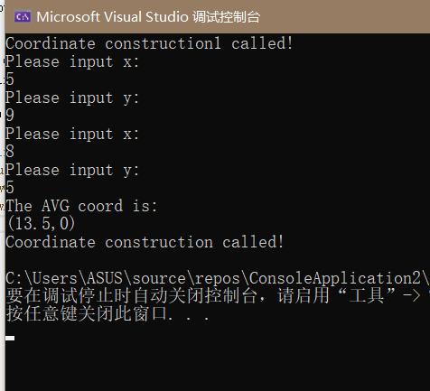

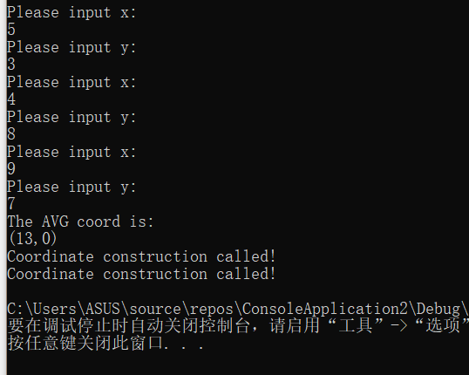

程序代码：

#include<iostream>

using namespace std;

class Score {

public:

Score()

{

Students = 2;

}

Score(int number)

{

Students = number;

}

~Score()

{

}

int i = 1;

void getgrade()

{

for (i = 1; i <= Students; i++) {

cout << "请输入学生姓名：" << endl;

cin >> name[i];

cout << "请输入科目A的成绩：" << endl;

cin >> a[i];

cout << "请输入科目B的成绩：" << endl;

cin >> b[i];

cout << "请输入科目C的成绩：" << endl;

cin >> c[i];

}

}

void showgrade()

{

for (i = 1; i <= Students; i++)

{

cout << "姓名：" << name[i] << "科目A的成绩：" << a[i] << " " << "科目B的成绩：" << b[i] << " " << "科目C的成绩：" << c[i] << " " << endl;

}

}

void showavgstu()

{

for (i = 1; i <= Students; i++)

{

cout << name[i] << ":" << ((a[i] + b[i] + c[i]) / 3);

}

}

void showclassgrade(char f)

{

float avg = 0;

if (f == 'a')

{

for (i = 1; i <= Students; i++)

{

avg = avg + a[i];

}

avg = avg / Students;

cout << "课程名称:A" << "平均成绩:" << avg << endl;

}

if (f == 'b')

{

for (i = 1; i <= Students; i++)

{

avg = avg + a[i];

}

avg = avg / Students;

cout << "课程名称:B" << "平均成绩:" << avg << endl;

}

}

private:

int Students;

float a[100], b[100], c[100];

string name[100];

};

int main()

{

Score A;

A.getgrade();

A.showgrade();

A.showclassgrade('a');

A.showavgstu();

return 0;

}

运行结果：

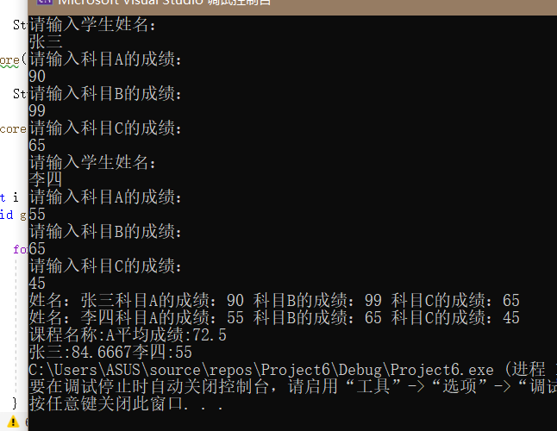

心得：在处理这个程序的时候，我一开始没有思绪。后来请教了同学才明白过来。这让我明白要多多向同学请教。

Copyright ©2021-2099 Haotian Wang. All rights reserved